
Lesson 14: Raising the Stakes
GDevelop
VIDEO GAME CREATION
This week: later waves get genuinely harder - more enemies, moving faster - using the exact wave variable you've had since Lesson 11.
Open your own [YourName]Game project from Lesson 13 - don't start a new one.
Tip: no new assets this week - difficulty scaling reuses your exact existing enemy sprites and spawn logic.

Setup
- Open your [YourName]Game project from Lesson 13.
- No new variables needed for Level 1 - Level 2 will use a new Speed variable on the Enemy object.

Level 1 - Minimal (MVP)
Each wave spawns one more enemy than the last (5, 6, 7). Speed stays the same for now - that's Level 2.
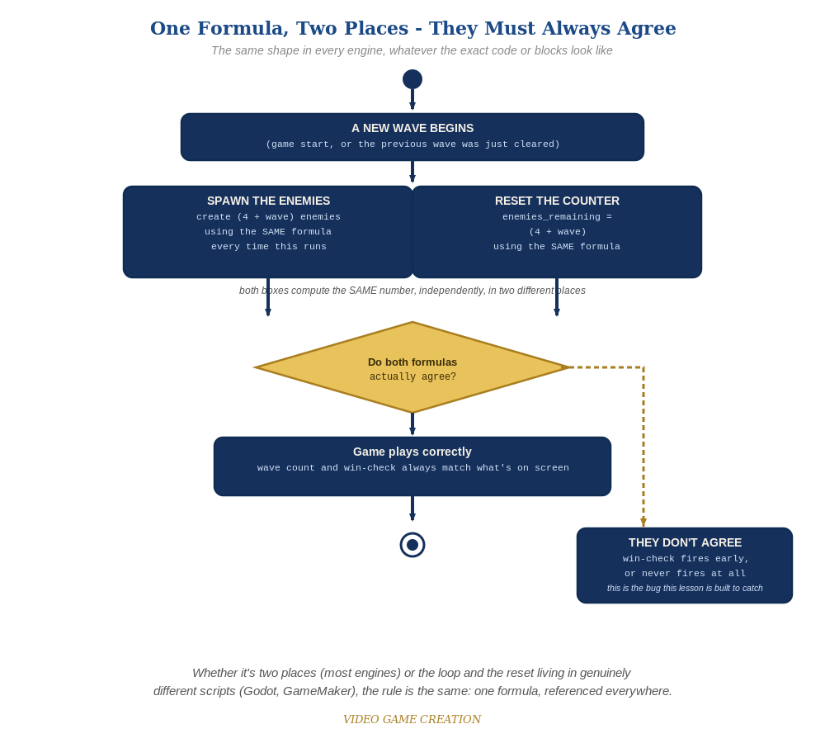
Whether the spawn loop and the reset live in two places or two genuinely different scripts, the rule is the same: one formula, referenced everywhere.
- On the Setup event group's "Repeat 5 times -> Create Enemy" action (and the matching one in the advance-wave event from Lesson 11), change the repeat count from a fixed 5 to the expression 4 + Wave (code below) - wave 1 spawns 5, wave 2 spawns 6, wave 3 spawns 7.
- Change EnemiesRemaining's reset value from a fixed 5 to the same 4 + Wave expression, in both events - these two places must always agree.
- Click Preview and play through a full round - wave 2 should visibly spawn one more enemy than wave 1, and wave 3 one more than that.
Highlighted lines are new this week; everything else is code you already have.
Setup event group (revised):
Action: Repeat (4 + Wave) times -> Create object Enemy
Action: EnemiesRemaining = 4 + Wave
Advance-wave event (revised, from Lesson 11):
Action: Wave = Wave + 1
Action: EnemiesRemaining = 4 + Wave
Action: Repeat (4 + Wave) times -> Create object Enemy

Level 2 - Complete (Alpha/Beta)
Enemy speed ALSO increases each wave, on top of the growing count. Restarting correctly returns everything to wave 1's original values.
- Add a new object variable, Speed, on the Enemy object (default value 30).
- On the same Create-Enemy actions, add: Change Speed of Enemy to (30 + (Wave - 1) * 10).
- Change the Enemy's existing downward-movement action to use Enemy.Variable(Speed) instead of a fixed number.
- Restart mid-game and confirm both count and speed return correctly to wave 1's values.
- Play a full round and confirm wave 3 is noticeably busier and faster than wave 1, but still fair.

Level 3 - Refined - Choose ONE Stretch Feature
Pick exactly one of the five ideas below. These are intentionally open-ended - a good-faith attempt at the general idea is a complete Level 3 finish, not a fully polished feature.
- Destructible shields/barriers: a few simple blocks placed between the player and the enemies that disappear (or shrink) after absorbing a hit or two - reuses your existing collision-detection and hit-reaction patterns from Lessons 4 and 13, just on a new kind of object.
- A power-up: an item that occasionally drops or spawns, which the player collects to temporarily change how shooting works (faster fire rate, multiple bullets at once, or a brief shield) - reuses your existing timer/cooldown pattern from Lesson 3.
- A bonus enemy: a rare, faster-moving, or oddly-patterned enemy worth extra points, spawned occasionally alongside a normal wave - reuses this week's own speed/count scaling ideas, just for one special case instead of the whole wave.
- Formation-marching movement: instead of each enemy independently drifting down (this course's approach since Lesson 4), have the whole wave move together as a group and occasionally step sideways - a genuinely different movement pattern, inspired by classic arcade shooters.
- A title screen and/or game-over screen: a proper opening screen (press a key to start) and/or a dedicated game-over screen with a final score, instead of just text overlaid on the gameplay - reuses your existing game_active flag and UI tools from Lessons 9-10. GDevelop's Panel Sprite and layer-switching actions are a natural fit for a title/game-over screen.

If Something's Wrong
- Every wave still spawns exactly 5: confirm both the Setup group and the advance-wave event actually use the (4 + Wave) expression, not a leftover fixed 5.
- WinText fires early or never: confirm EnemiesRemaining is reset using the SAME expression in every event that sets it.
- Speed doesn't change between waves: confirm the Enemy's movement action is actually reading its Speed variable, not a leftover fixed number.

Want More?
Student Resource List > GDevelop section, or wiki.gdevelop.io

